DESIGN DOCUMENT

GPA Analyzer & Predictor
Project Name: GPA Analyzer & Predictor
Developer: Hanaa Mohammed Kari
Organization: Flexisaf Educational Technology
Date: December 2025
Version: 1.0

1. INTRODUCTION

1.1 Purpose
This document describes the system design, architecture, and implementation approach for the GPA Analyzer & Predictor project.

1.2 Scope
This document covers:
- System architecture
- Data models and structures
- Algorithm designs
- Module specifications
- Technology stack decisions

1.3 Audience
- Development team
- Technical reviewers
- Future maintainers
- Project stakeholders

2. SYSTEM ARCHITECTURE

2.1 High-Level Architecture
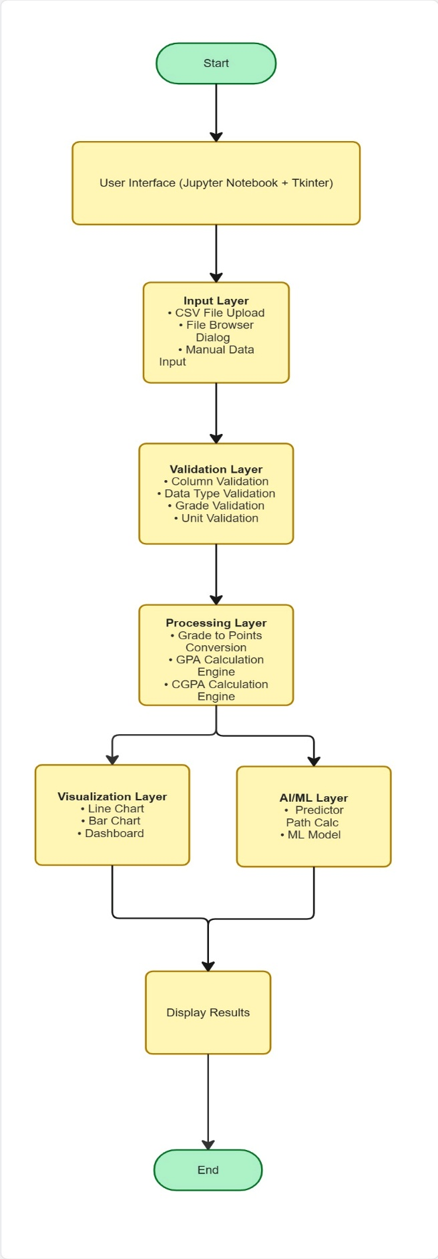

2.2 Data Flow
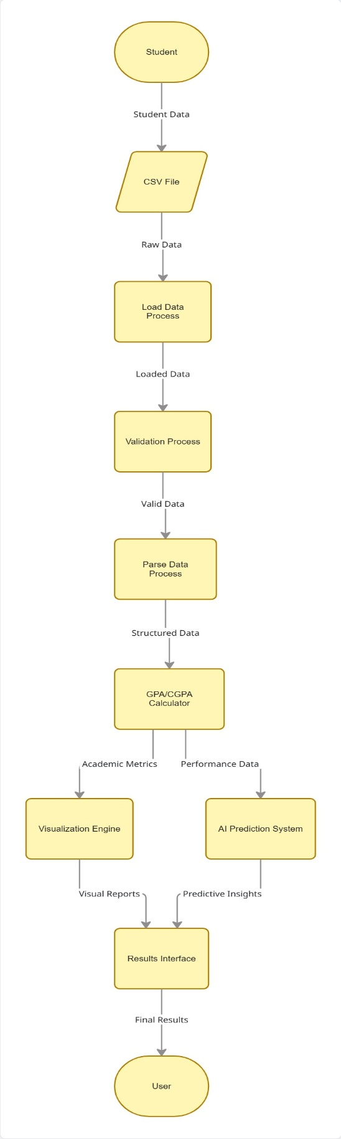

3. DATA MODELS

3.1 Input Data Structure (CSV)
CSV Format:
Semester,Course,Units,Grade
1,Introduction to Computing,3,A
1,Calculus I,4,B
2,Data Structures,3,A
Column Specifications:
Column | Type | Constraints | Example
Semester | Integer | >= 1 | 1, 2, 3
Course | String | Non-empty | "Mathematics"
Units | Integer | 1-10 | 3, 4, 5
Grade | String | A, B, C, D, E, F | "A", "B"

3.2 Internal Data Structures
Grade Points Dictionary:
grade_points = {
'A': 5.0,
'B': 4.0,
'C': 3.0,
'D': 2.0,
'E': 1.0,
'F': 0.0
}

Semester Data Structure:
semester = {
'semester': 'Semester 1', # String identifier
'courses': [list of courses], # List of strings
'grades': [list of grades], # List of strings (A-F)
'units': [list of units] # List of integers
}
CGPA Result Structure:
result = {
'cgpa': 4.17, # Float (0.0-5.0)
'semester_gpas': [ # List of dictionaries
{'semester': 'Semester 1', 'gpa': 4.08},
{'semester': 'Semester 2', 'gpa': 3.92}
],
'total_points': 150.0, # Float
'total_units': 36 # Integer
}

4. ALGORITHM DESIGNS

4.1 GPA Calculation Algorithm
Purpose: Calculate weighted average GPA for one semester
Input: Lists of courses, grades, units
Output: GPA value (0.0-5.0)
Algorithm:
1. Initialize: total_points = 0, total_units = 0
2. For each course in semester:
a. Convert grade to points using grade_points dictionary
b. Calculate weighted_points = points × units
c. Add weighted_points to total_points
d. Add units to total_units
3. Calculate GPA = total_points ÷ total_units
4. Return GPA

4.2 CGPA Calculation Algorithm
Purpose: Calculate cumulative GPA across multiple semesters
Input: List of semester data
Output: CGPA and semester breakdown
Algorithm:
1. Initialize: cumulative_points = 0, cumulative_units = 0
2. For each semester:
a. Calculate semester GPA using GPA algorithm
b. Calculate semester_points = semester_gpa × semester_units
c. Add semester_points to cumulative_points
d. Add semester_units to cumulative_units
e. Store semester GPA in results list
3. Calculate CGPA = cumulative_points ÷ cumulative_units
4. Return CGPA and semester_gpas list

4.3 Scenario Prediction Algorithm
Purpose: Predict future CGPA based on performance scenario
Input: Current CGPA, current units, next semester units, scenario type
Output: Predicted CGPA with explanation
Algorithm:
1. Calculate current_points = current_cgpa × current_units
2. Define adjustment factors:
- improve: +0.4
- maintain: 0.0
- decline: -0.3
3. Calculate predicted_next_gpa = current_cgpa + adjustment
4. Bound prediction: max(0.0, min(5.0, predicted_next_gpa))
5. Calculate next_semester_points = predicted_next_gpa × next_units
6. Calculate new_cgpa = (current_points + next_semester_points) ÷ (current_units + next_units)
7. Return prediction with explanation
Rationale: Uses empirical data on typical student performance changes

4.4 Path to Target Algorithm
Purpose: Calculate required GPA to reach target CGPA
Input: Current CGPA, current units, target CGPA, remaining units
Output: Required average GPA and feasibility
Algorithm:
1. Calculate current_points = current_cgpa × current_units
2. Calculate total_future_units = current_units + remaining_units
3. Calculate target_points = target_cgpa × total_future_units
4. Calculate points_needed = target_points - current_points
5. Calculate required_gpa = points_needed ÷ remaining_units
6. Check feasibility: 0.0 ≤ required_gpa ≤ 5.0
7. Assign difficulty rating:
- < current_cgpa: EASY
- < 4.0: MODERATE
- < 4.5: CHALLENGING
- >= 4.5: VERY DIFFICULT
8. Return required_gpa, feasibility, and recommendations
Mathematical Foundation: Solves the equation:
(current_points + x × remaining_units) ÷ total_units = target_cgpa
Where x is the required GPA we solve for

4.5 Machine Learning Algorithm
Purpose: Learn from past performance to predict future
Algorithm: Linear Regression
Training Process:
1. Prepare data:
- X = semester numbers [1, 2, 3, ...]
- y = GPA values [4.2, 4.0, 4.5, ...]
2. Create LinearRegression model
3. Fit model: model.fit(X, y)
- Model learns: y = mx + b
- m = slope (trend direction)
- b = intercept (starting point)
4. Return trained model
Prediction Process:
1. For future semester n:
- Create X_new = [[n]]
- Predict: y_pred = model.predict(X_new)
2. Bound prediction: max(0.0, min(5.0, y_pred))
3. Return predicted GPA
Why Linear Regression:
- Simple and interpretable
- Works well with small datasets (3-10 semesters)
- Naturally extrapolates trends
- Fast to train and predict

5. MODULE SPECIFICATIONS

5.1 Data Loading Module
Module: load_csv_simple(filepath)
Purpose: Load and validate CSV file
Input: File path string
Output: Structured semester data or None
Functions:
- load_csv_simple() - Main loader
- simple_validate_csv() - Validation logic
Dependencies: pandas, os
Error Handling:
- File not found → Return None, show error
- Invalid format → Return None, show specific error
- Missing columns → Return None, list missing columns

5.2 Calculation Module
Functions:
- grade_to_points(grade) - Convert letter to number
- calculate_gpa(courses, grades, units) - Semester GPA
- calculate_cgpa(semesters_data) - Cumulative GPA
Design Principles:
- Each function has single responsibility
- Pure calculations (no side effects)
- Return values, don't modify inputs
- Comprehensive docstrings

5.3 Visualization Module
Functions:
- plot_gpa_trend(result) - Line chart
- plot_semester_comparison(result) - Bar chart
- create_dashboard(result) - Combined view
Library: Matplotlib
Design Decisions:
- Use color coding for clarity (green/orange)
- Add value labels on all data points
- Include CGPA reference line
- Consistent styling across charts

5.4 AI Prediction Module
Functions:
- predict_scenario() - Scenario-based prediction
- simple_path_calculator() - Goal planning
- train_simple_model() - ML training
- predict_next_semester() - ML prediction
Library: Scikit-learn
Design Philosophy:
- Keep predictions simple and explainable
- Always bound predictions to valid range
- Provide confidence context with predictions
- Clear warnings that predictions are estimates

5.5 Integration Module
Function: Complete Workflow (Cell 32)
Purpose: Orchestrate entire system
Flow:
- File selection/loading
- Data validation
- CGPA calculation
- Visualization generation
- AI predictions
- Results display
Design: Sequential execution with error handling at each stage

6. TECHNOLOGY STACK

6.1 Core Technologies
Programming Language: Python 3.8+
- Why: Rich data science ecosystem, beginner-friendly
- Alternatives Considered: R (less versatile), JavaScript (weaker for data science)
Development Environment: Jupyter Notebook
- Why: Interactive, combines code and documentation, industry standard for data science
- Alternatives Considered: VS Code (less interactive), PyCharm (heavier)

6.2 Libraries
Pandas (2.0+)
- Purpose: Data loading, manipulation, cleaning
- Why: De facto standard for data processing in Python
- Usage: CSV reading, DataFrame operations, data validation
Matplotlib (3.7+)
- Purpose: Data visualization
- Why: Mature, well-documented, highly customizable
- Usage: Line charts, bar charts, dashboards
Scikit-learn (1.3+)
- Purpose: Machine learning
- Why: Industry standard, excellent documentation, simple API
- Usage: Linear Regression model
NumPy (included with scikit-learn)
- Purpose: Numerical operations
- Why: Required by scikit-learn, efficient array operations
- Usage: Array reshaping for ML input
Tkinter (built-in)
- Purpose: GUI file browser
- Why: Built into Python, no extra installation
- Usage: File selection dialog

7. USER INTERFACE DESIGN

7.1 Interface Type
Jupyter Notebook Cell-Based Interface
Rationale:
- Familiar to data science users
- Step-by-step execution
- Combines code, output, and documentation
- Easy to modify and experiment

7.2 User Interaction Flow
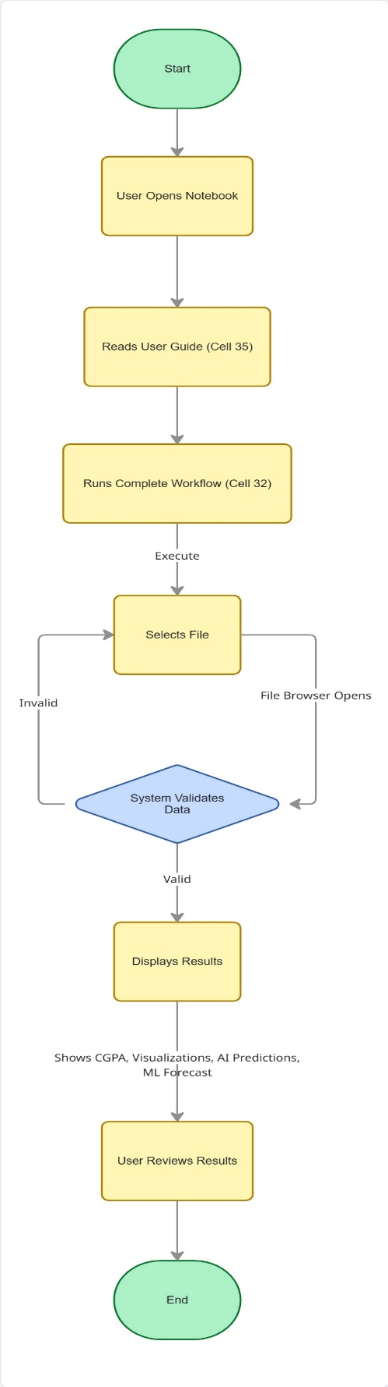

7.3 Error Display Strategy
Validation Errors:
Invalid grade 'Z' in row 4
Valid grades are: A, B, C, D, E, F
Tip: Check your CSV file and fix the error
File Errors:
File 'grades.csv' not found!
Please check the file path and try again.
Design Principle: Always tell user:
- What went wrong
- Why it's a problem
- How to fix it

8. DATA VALIDATION DESIGN

8.1 Validation Layers
Layer 1: File Level
- File exists
- File is readable
- File is CSV format
Layer 2: Structure Level
- Required columns present
- No empty DataFrame
Layer 3: Data Type Level
- Semester is numeric
- Units is numeric
- Grade is string
Layer 4: Business Logic Level
- Grades are A-F only
- Units are positive
- Semesters are >= 1

8.2 Validation Flow
def validate():
if not file_exists:
return ERROR
if not has_columns:
return ERROR
if has_invalid_grades:
return ERROR
if has_invalid_units:
return ERROR
return SUCCESS

9. PERFORMANCE CONSIDERATIONS

9.1 Expected Performance
Operation | Data Size | Expected Time
Load CSV | 100 courses | < 1 second
Calculate CGPA | 10 semesters | < 0.5 seconds
Generate charts | 10 semesters | < 2 seconds
Train ML model | 6 semesters | < 0.1 seconds
Complete workflow | 100 courses | < 5 seconds

9.2 Optimization Strategies
Data Loading:
- Use pandas built-in CSV parser (optimized C code)
- Read only required columns
- Minimal data copying
Calculations:
- Vectorized operations where possible
- Avoid unnecessary loops
- Cache CGPA result for reuse
Visualizations:
- Generate charts only when needed
- Reuse figure objects
- Minimal chart complexity

10. ERROR HANDLING STRATEGY

10.1 Error Categories
1. User Errors
- Invalid file format
- Missing columns
- Invalid data values → Action: Show helpful message, suggest fix
2. System Errors
- Library not installed
- File permission denied → Action: Show technical error, suggest solution
3. Logic Errors
- Division by zero (no units)
- Empty data → Action: Use safe defaults, warn user

10.2 Error Handling Pattern
try:
# Operation
result = risky_operation()
except SpecificError as e:
# Handle gracefully
print("❌ Specific error occurred")
print(f" Details: {e}")
return None
Principle: Never crash, always inform

11. TESTING STRATEGY

11.1 Test Types
Unit Tests:
- Test each function independently
- Known inputs → expected outputs
- Edge cases (empty data, maximum values)
Integration Tests:
- Test complete workflow
- CSV load → calculate → visualize
- Verify data flows correctly
Validation Tests:
- Test error detection
- Invalid grades, negative units
- Missing columns
11.2 Test Data
Sample Data:
- Perfect student (all A's)
- Struggling student (C's and D's)
- Improving trend (C → B → A)
- Declining trend (A → B → C)
Edge Cases:
- Single semester
- Many semesters (10+)
- All same grades
- Maximum units

12. FUTURE EXTENSIBILITY

12.1 Design for Extension
Modular Architecture:
- Easy to add new AI features
- Visualization functions are independent
- Calculation logic is separate from display
Possible Extensions:
- Add new grading scales
- Support different GPA formulas
- Add more ML models
- Export to different formats

12.2 Extension Points
Adding New Visualizations:
def new_chart(result):
# Uses same result structure
# Add new chart type
pass
Adding New AI Features:
def new_predictor(current_cgpa, ...):
# Uses same data structures
# New prediction algorithm
pass

13. SECURITY CONSIDERATIONS

13.1 Data Privacy
- No data transmitted over network
- No external API calls (except optional)
- Data stays on user's machine
- No data persistence (unless user saves)

13.2 Input Sanitization
- Validate all user inputs
- No SQL (no database)
- No shell commands
- No code execution from CSV

14. DEPLOYMENT CONSIDERATIONS

14.1 Installation Requirements
System Requirements:
- Python 3.8 or higher
- 100MB free disk space
- GUI support (for file browser)
Installation Steps:
- Install Python
- Install dependencies: pip install pandas matplotlib scikit-learn
- Download notebook file
- Run Jupyter: jupyter notebook

15. MAINTENANCE PLAN

15.1 Code Maintenance
Documentation:
- All functions have docstrings
- Complex logic has inline comments
- User guide is comprehensive
Version Control:
- Track changes in Git
- Meaningful commit messages
- Tag releases

